Guided Capstone Project Report

Before the start of the season, Big Mountain Resort (BMR) wants to create an effective price modelling strategy to offset $1.54 million in operation costs for adding another chair lift to their resort. The current price for each ticket is listed to be $81.00 per day for one person. After doing a thorough analysis of other resorts and the prices they charge for the facilities provided, the modelled ticket price for BMR should be $94.22. Such a jump in ticket prices can be explained to be appropriate by the facilities BMR provides for customers.

Looking at the distribution of facilities in the ski resort market, BMR provides exceptional facilities for visitors.

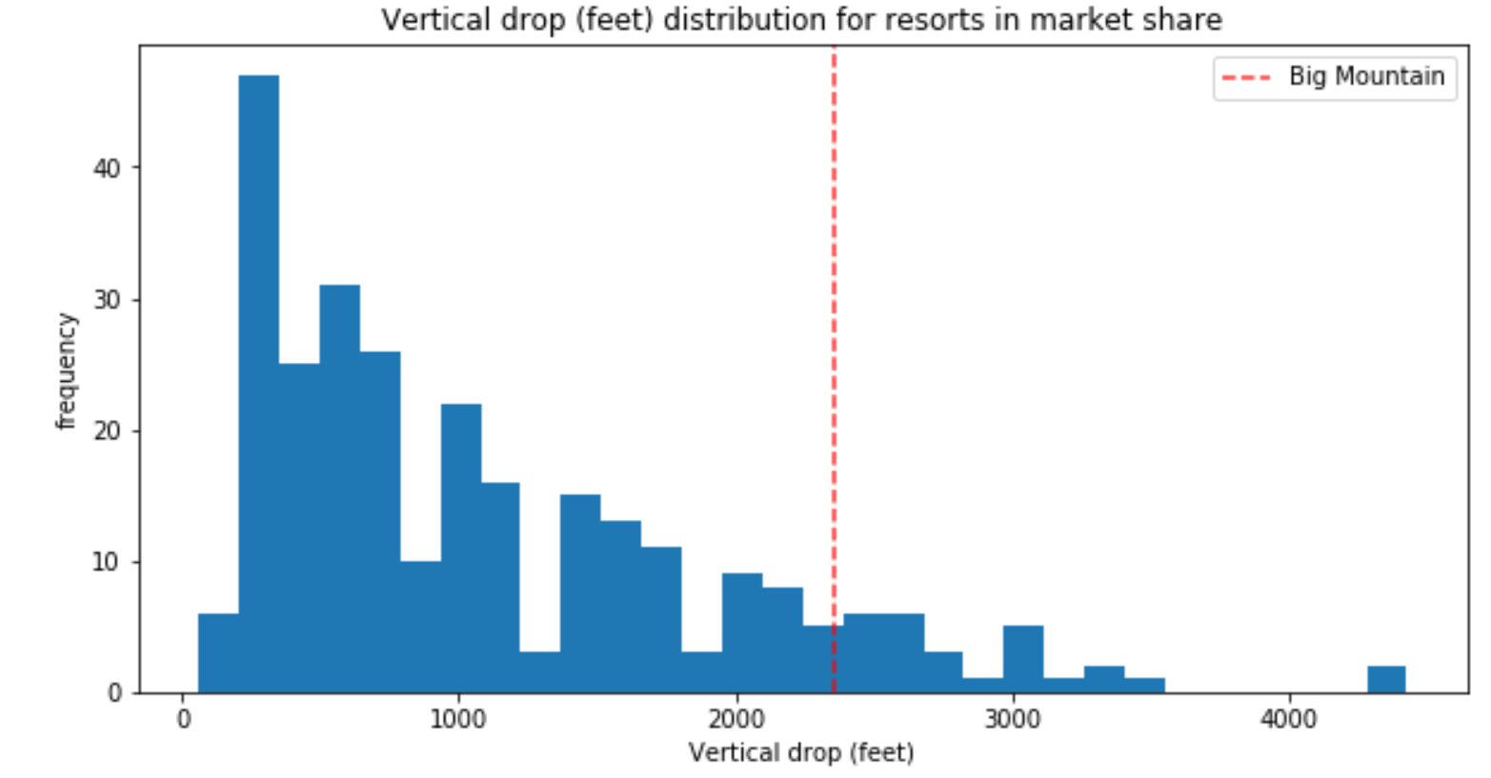

Vertical drop adds a thrill to the skiing experience which is sought by many skiers alike. Looking at the market distribution of vertical drops, BMR provides a greater drop compared to many other ski resorts in the country, while there are a few resorts which boast a greater drop.

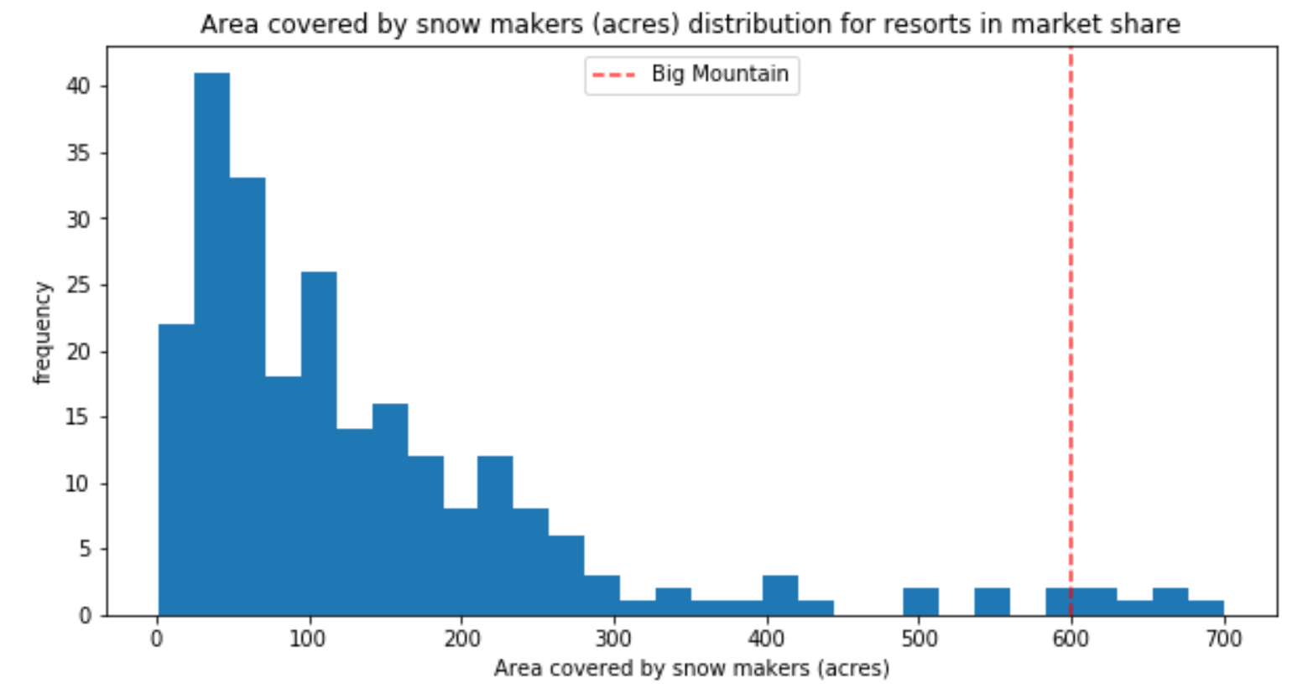

Snow provides an aesthetic element to any resort and is a viable component for a pleasant skiing experience. BMR resort has 600 acres of area covered by snow, while a greater distribution of ski resorts covers between 0-200 acres of area.

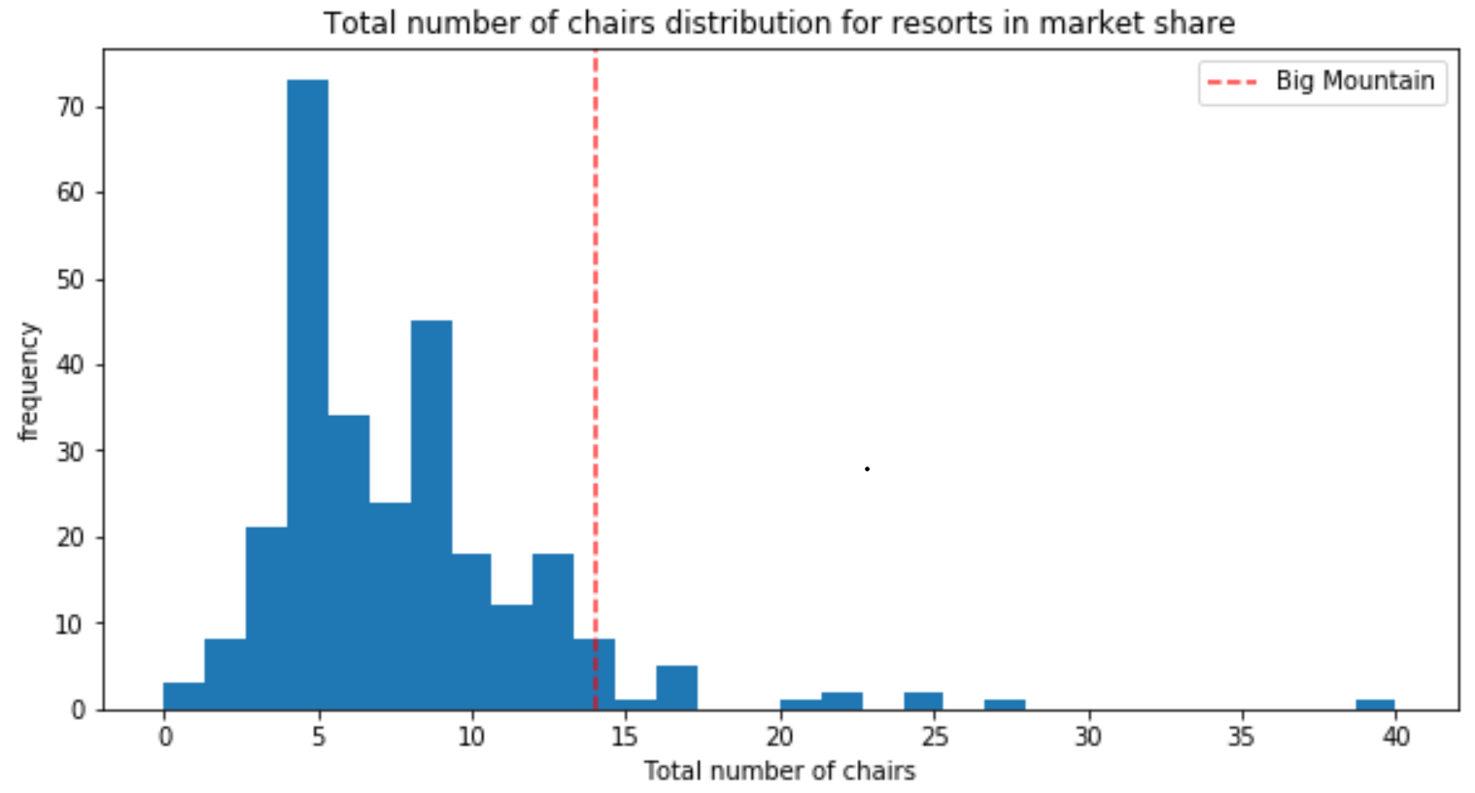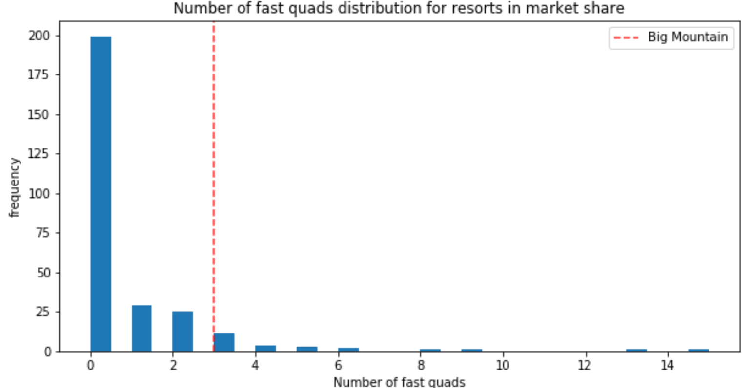

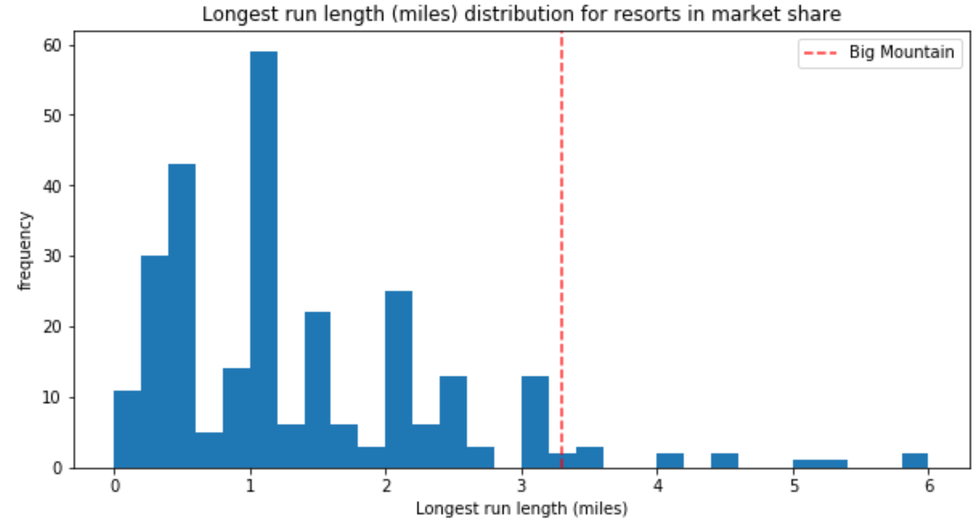

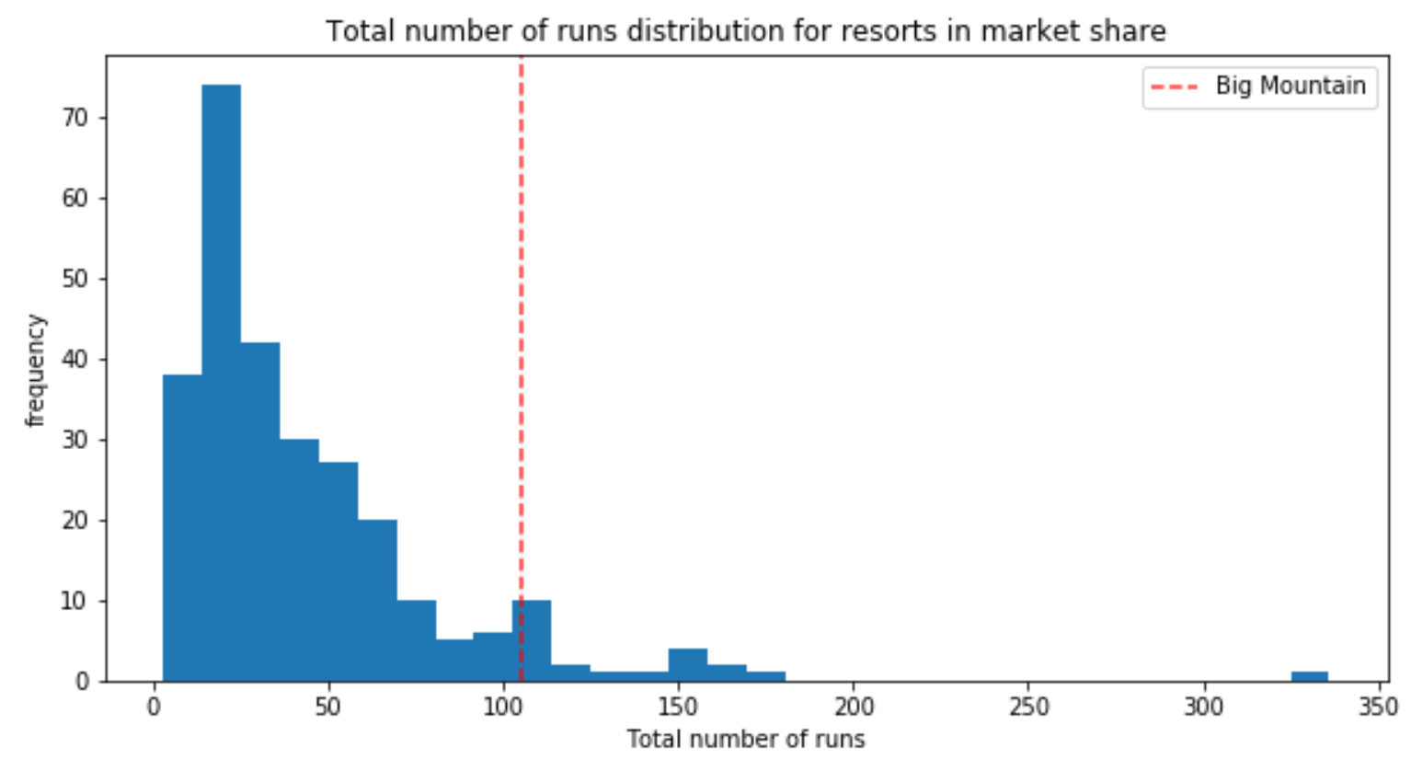

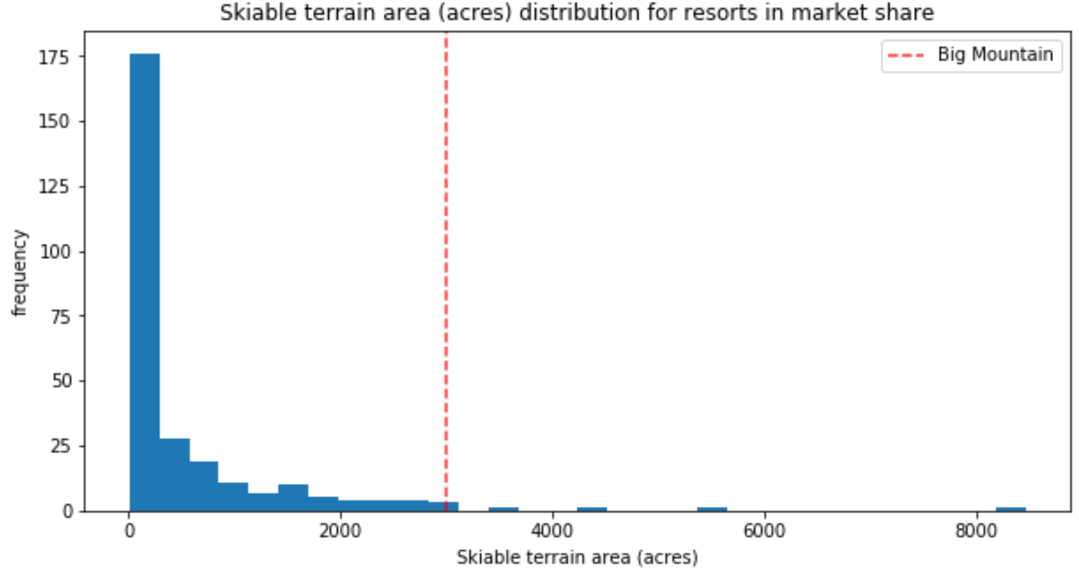

A look at other facilities (Total number of chairs, number of fast quads, longest run, total number of runs, and skiable terrain acres) show that BMR provides a lot of facilities which can be enjoyed by greater distribution of visitors and provides their visitors with ease of access and a wide variety of runs to ensure satisfaction.

Looking at the distribution of BMR’s facilities compared with other resort’s facilities does provide enough evidence as to why the modelled price should replace the current ticket price.

After doing further analysis to see change in ticket price and revenue in a scenario where BMR decided to close between 1 to 10 of its runs, BMR can close only one of its runs without seeing any losses in revenue or decrease in ticket prices.

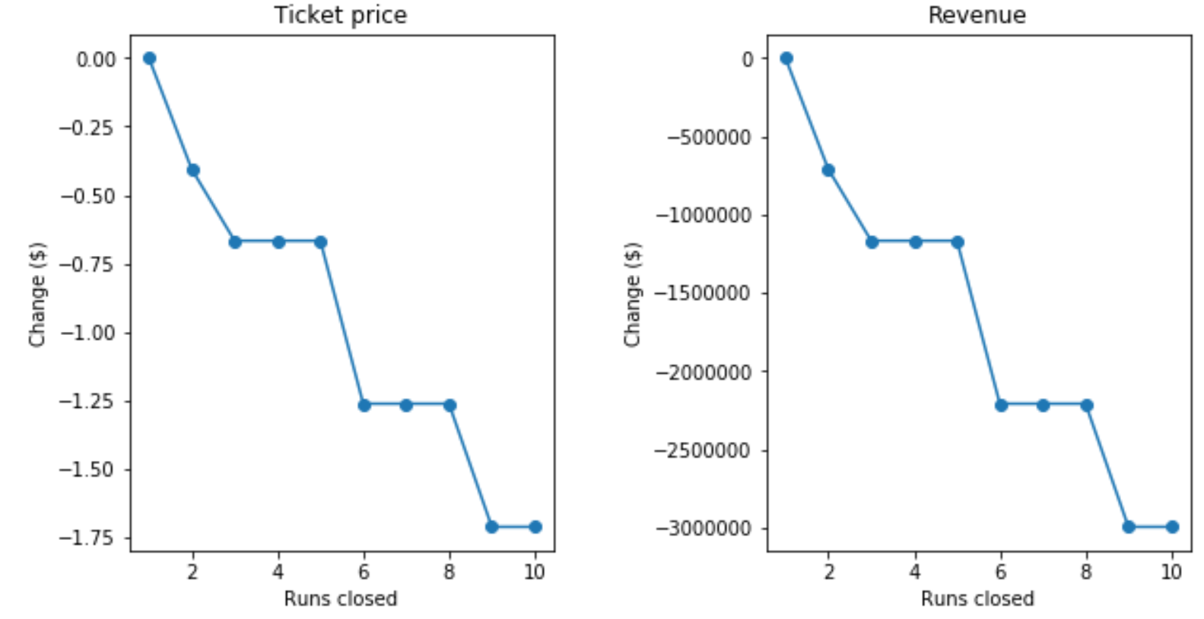

Seeing that BMR wants to offset a price of $1.54 million before the start of the season, it would be best if they invest in increasing runs by 1, creating a steeper drop with an additional 150 ft, add an additional chair lift, and increase snow cover by 2 acres. Such an investment will increase the ticket price by $9.75 per day and create an additional revenue of $1.7 million which overbalances the operational costs.